**Programming Challenges 1A and B September 18, 2018 - Due on or before 10:10pm**

**Objective:** Basic functions and arrays

|  |
| --- |
| **Important instructions:**   * *All programs must include comments at the top of your program: your name, course name-section number (e.g. CSIT 839 -26953), program name and the program description in brief.* * *Copy and paste your program code and outputs in Part B of each program.* * *Once it is done, save and submit this word file via Canvas.* |

**1. FindOccOfLargest.cpp (10 pts)**

Write a program that prompts the user to enter 6 integer numbers. The program finds and displays the largest numbers, smallest numbers and number of occurrence elements of the largest numbers.

**Sample Output:**

You can enter six integer numbers.

Enter a number: 5

Enter a number: -12

Enter a number: 25

Enter a number: 19

Enter a number: -8

Enter a number: 25

The array elements are: 5 -12 25 19 -8 25

The largest number is 25

The smallest number is -12

The occurrence count of the largest number is 2

**Pseudocode of the main program**

// Read six numbers from the user and store in an array

// Find the largest and smallest elements of the array using for loop

// Find the occurrence of the largest number using for loop

// Display the results.

**Copy and paste your program (source) code and the outputs after this line**

**+++++++++++++++++++++++++++++++++++++++++++++++++**

/*

FindOccOfLargest.cpp

Inola Cohen

CSIT 839 - 26953

Purpose: to write a program that prompts the user

to enter 6 integers. The program finds and displays

the largest numbers, smallest numbers, and number of

occurrence elements of the largest numbers.

Pseudocode:

1. Read 6 numbers from the user and store in array

2. Find the largest and smallest elements of the

array using for loop

3. Find the occurrence of the largest number using for loop

4. Display the results

*/

//#include “stdafx.h”

#include <iostream>

using namespace std;

int main() {

int NUM_SIZE = 6;

int numArray[NUM_SIZE], i, largestCount = 0;

int smallest, largest;

/* Get user input for 6 numbers & store in array */

cout << "You can enter six integer numbers." << endl;

for (i = 0; i < NUM_SIZE; i++)

{

cout << "Enter a number: ";

cin >> numArray[i];

}

/* Display array elements */

cout << "The array elements are: ";

for (i = 0; i < NUM_SIZE; i++)

{

cout << numArray[i] << " ";

}

cout << endl;

smallest = numArray[0];

largest = numArray[0];

/* Find the largest number */

for (i = 1; i < NUM_SIZE; i++)

{

if (numArray[i] > largest)

{

largest = numArray[i];

}

}

cout << "The largest number is " << largest << endl;

/* Find the smallest number */

for (i = 1; i < NUM_SIZE; i++)

{

if (numArray[i] < smallest)

{

smallest = numArray[i];

}

}

cout << "The smallest number is " << smallest << endl;

/* Find the occurrence of the largest number */

for (i = 0; i < NUM_SIZE; i++)

{

if (largest == numArray[i])

{

largestCount++;

}

}

cout << "The occurrence count of the largest number is " << largestCount << endl << endl;

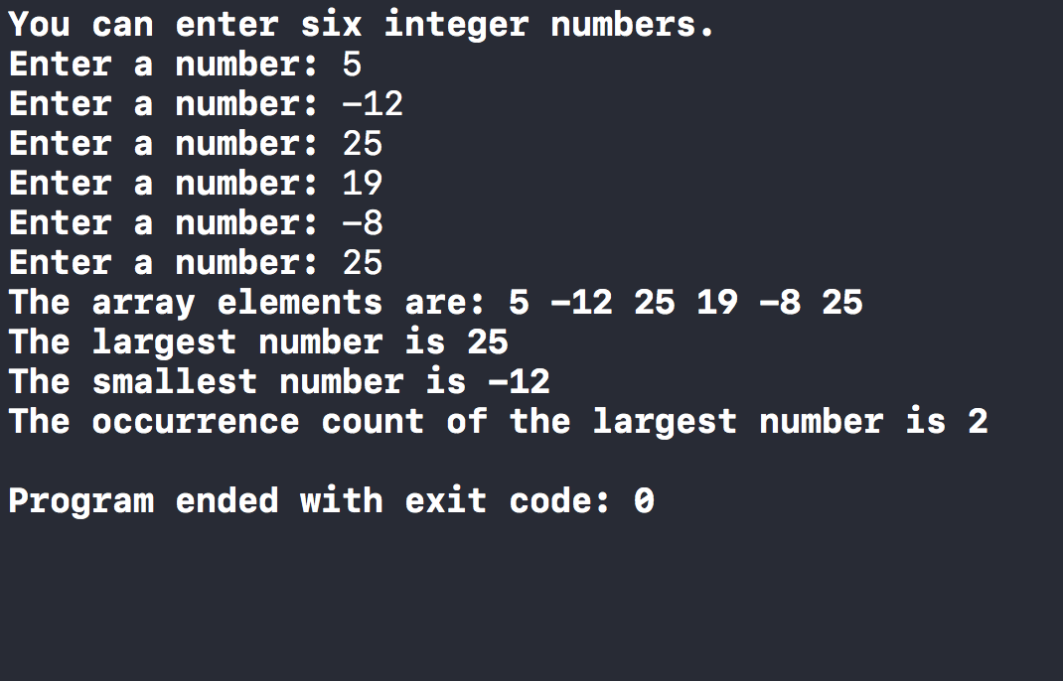

return 0;

}

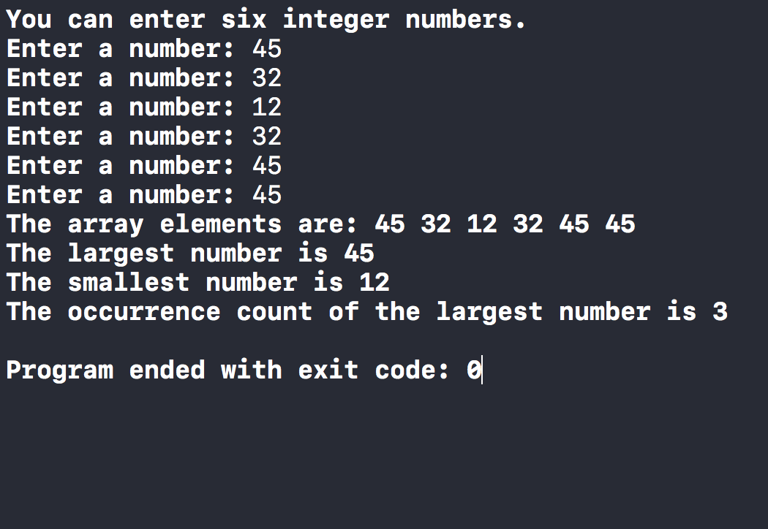

**2. FindIndexes.cpp (15 pts)**

Write a program, FindIndexes.cpp, that generates 15 integers randomly from 1 to 100 and stores in an array. The program will find the **first occurrence of the smallest element** and the **last occurrence of the largest element** in the array.

Function prototypes:

const int ARRAY_SIZE = 15;

void printArray(const int list[], int sizeX);

To display the list of random number of array.

int lastLargestIndex(const int list[], int sizeX);

To find the last largest element of the array.

int firstSmallestIndex(const int list[], int sizeX);

To find the last smallest element of the array.

**Pseudocode of main program**

// generate a random array

// print random array

// Display the largest element and its position;

// Display the smallest element and its position;

**Sample Output 1:**

List elements: 36 99 21 42 58 62 18 25 68 13 56 48 3 25 48

The largest element in this list is 99 at the position [2]

The smallest element in this list is 3 at the position [13]

**Sample Output 2:**

List elements: 99 64 25 91 66 90 1 33 79 21 61 51 34 41 44

The largest element in this list is 99 at the position [1]

The smallest element in this list is 1 at the position [7]

**Copy and paste your program (source) code and the outputs after this line**

**+++++++++++++++++++++++++++++++++++++++++++++++++**

/*

FindIndexes.cpp

Inola Cohen

CSIT 839 - 26953

Purpose: to write a program that generates 15

integers randomly from 1 to 100 and stores in

an array. The program will find the first occurrence

of the smallest element and the last occurrence of the

largest element in the array.

Pseudocode:

1. generate a random array

2. print random array

3. display the largest element and its position

4. display the smallest element and its position

*/

//#include "stdafx.h" --> // doesn't work on mac

#include <iostream>

using namespace std;

/* Function Prototypes */

const int ARRAY_SIZE = 15;

void printArray(const int[], int);

int lastLargestIndex(const int[], int);

int firstSmallestIndex(const int[], int);

int main()

{

int numbersArray[ARRAY_SIZE], i, j = 0, k = 0;

int largestNumber, smallestNumber;

unsigned int seed;

seed = time(0);

srand(seed);

cout << "List elements: ";

for (i = 0; i < ARRAY_SIZE; i++)

{

numbersArray[i] = rand() % 100;

}

/* Pass randomly-generated array to print function */

printArray(numbersArray, ARRAY_SIZE);

largestNumber = lastLargestIndex(numbersArray, ARRAY_SIZE);

for (i = 0; i < ARRAY_SIZE; i++)

{

if (largestNumber == numbersArray[i])

{

j = i;

}

}

smallestNumber = firstSmallestIndex(numbersArray, ARRAY_SIZE);

for (i = 0; i < ARRAY_SIZE; i++)

{

if (smallestNumber == numbersArray[i])

{

k = i;

}

}

cout << "The largest element in this list is " << largestNumber

<< " at the position [" << j + 1 << "]" << endl;

cout << "The smallest element in this list is " << smallestNumber

<< " at the position [" << k + 1 << "]" << endl << endl;

return 0;

}

void printArray(const int list[], int sizeX)

{

int i;

for (i = 0; i < sizeX; i++)

{

cout << list[i] << " ";

}

cout << endl << endl;

}

int lastLargestIndex(const int list[], int sizeX)

{

int largest = list[0], i;

for (i = 0; i < sizeX; i++)

{

if (list[i] > largest)

{

largest = list[i];

}

}

return largest;

}

int firstSmallestIndex(const int list[], int sizeX)

{

int smallest = list[0], i;

for (i = 0; i < sizeX; i++)

{

if (list[i] < smallest)

{

smallest = list[i];

}

}

return smallest;

}

